DB MODEL :

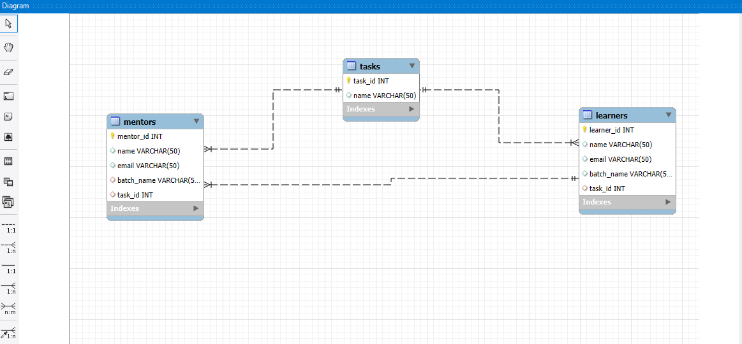

Queries:

create table tasks(task_id int primary key, name varchar(50));

insert into tasks(task_id,name) values (1,"states"),(2,"routing"),(3,"redux");

describe tasks;

create table learners(learner_id int primary key, name varchar(50), email varchar(50), batch_name varchar(50),

task_id int,UNIQUE KEY (batch_name),

foreign Key(task_id) references tasks(task_id)) ;

insert into learners(learner_id,name,email,batch_name,task_id) values

(1,'john','john@gmail.com','batch1',1),

(2,'doe','doe@gmail.com','batch2',2),

(3,'bob','bob@gamil.com','batch3',3);

describe learners;

create table mentors(mentor_id int primary key, name varchar(50),email varchar(50), batch_name varchar(50),task_id int,

foreign Key(batch_name) references learners(batch_name),

foreign Key(task_id) references tasks(task_id));

insert into mentors(mentor_id,name,email,batch_name,task_id) values

(1,'Michael Wilson','michael.wilson@example.com','batch1',1),

(2,'Paul Smith','paul.smith@example.com','batch2',2),

(3,'Emily Davis','emily.davis@example.com','batch3',3);

describe mentors;